Tunisia

## Political Stability Estimate Data

The data set shows the political stability estimate of the country each year.

## # A tibble: 19 x 5  
## country iso3c date stability stabilityCategory4   
## <chr> <chr> <dbl> <dbl> <chr>   
## 1 Tunisia TUN 1996 0.263 moderately stable   
## 2 Tunisia TUN 1998 0.265 moderately stable   
## 3 Tunisia TUN 2000 0.325 moderately stable   
## 4 Tunisia TUN 2002 0.151 moderately stable   
## 5 Tunisia TUN 2003 0.319 moderately stable   
## 6 Tunisia TUN 2004 0.149 moderately stable   
## 7 Tunisia TUN 2005 0.0238 moderately stable   
## 8 Tunisia TUN 2006 0.211 moderately stable   
## 9 Tunisia TUN 2007 0.159 moderately stable   
## 10 Tunisia TUN 2008 0.102 moderately stable   
## 11 Tunisia TUN 2009 0.0618 moderately stable   
## 12 Tunisia TUN 2010 -0.0640 moderately unstable  
## 13 Tunisia TUN 2011 -0.354 moderately unstable  
## 14 Tunisia TUN 2012 -0.721 moderately unstable  
## 15 Tunisia TUN 2013 -0.903 moderately unstable  
## 16 Tunisia TUN 2014 -0.852 moderately unstable  
## 17 Tunisia TUN 2015 -0.960 moderately unstable  
## 18 Tunisia TUN 2016 -1.14 highly unstable   
## 19 Tunisia TUN 2017 -1.05 highly unstable

## Political Stability Estimate Plot

The plot shows the trends of stabilization and destabilization for the each country.

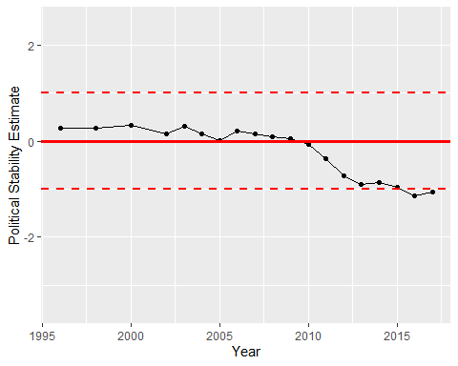

Political Stability Trend